**Weather Data Report**

**Observable trend 1:**

The scatter plot below shows that on average, temperatures are warmer approaching the equator and cooler approaching the Poles.

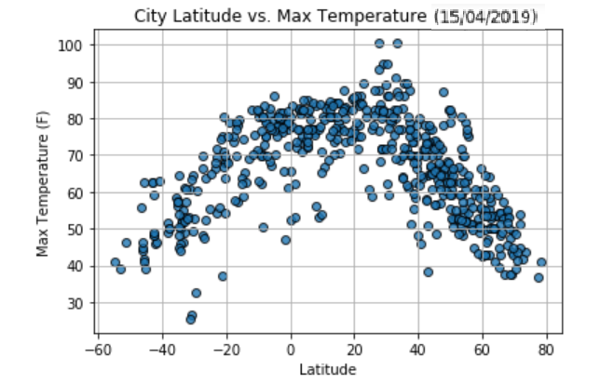

**Observable trend 2:**

The scatter plot below shows that humidity is higher in the tropics, the region that lies between 23.5 degrees north and 23.5 north of the equator.

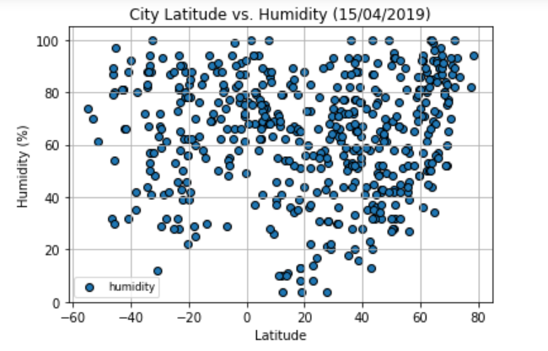

**Observable trend 3:**

The scatter plot below shows that there is higher cloudiness towards the South Pole than towards the North Pole

